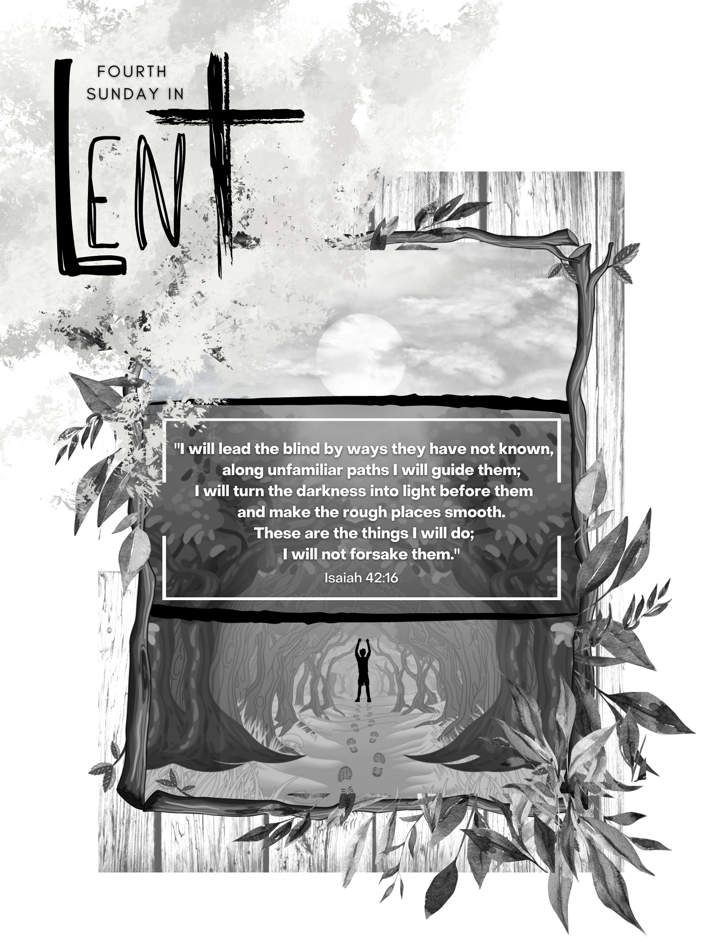

St. Lucas Evangelical Lutheran

Church and School
1417 Parkview Drive PO Box 44 Kewaskum, Wisconsin www.stlucaswels.org

The Fourth Sunday in Lent
March 19th, 2023

The Season
Lent is the season of the Church Year where we wrestle with our greatest needs. Lent also demonstrates that in Christ, all our greatest needs are met. Here is what the Spirit makes clear this season. If you lack Christ, you have nothing. If you have Christ, you have everything you truly need.

The Sunday
The Old Testament said that restoration of sight to the blind was one of the works of the Messiah. In his ministry, Jesus healed those who were physically blind. But even if our eyes work just fine, we still need Jesus to give us spiritual vision. Jesus said, “I am the light of the world.” Christ comes to shine his light into our darkened eyes that we might see him and live. Jesus meets our greatest needs. He provides sight for the spiritually blind.

Prayer before Worship
“I rejoiced with those who said to me, ‘Let us go to the house of the Lord.’” Give me joy, dear Jesus, as I prepare to worship you today. Make me understand what my life would be like without you so that I long to hear about your grace and compassion. Help me participate in a way that honors you and builds up all who worship with me, and let their worship strengthen and encourage my faith.

Serving in Worship

Presiding Minister: | Pastor Timothy Henning | Organist: | Coralee Henning
Ushers: | Kevin Kempf (8 am Sunday)  Jonathan Koch (10:30 am Sunday)
Christ Is the World’s Light CW 515
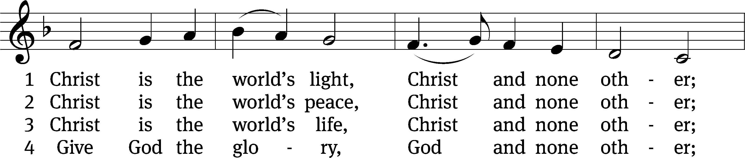
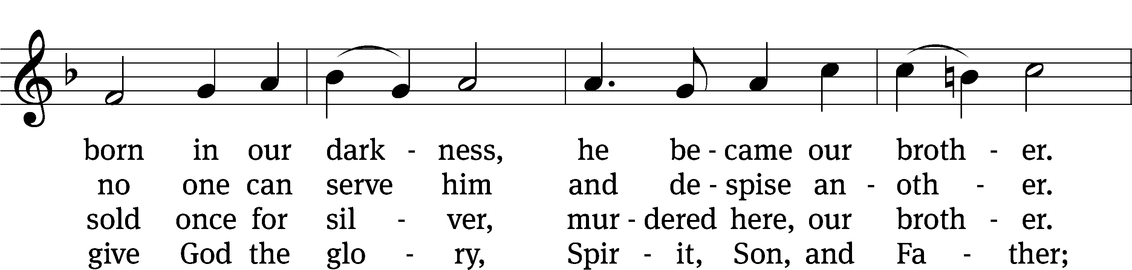
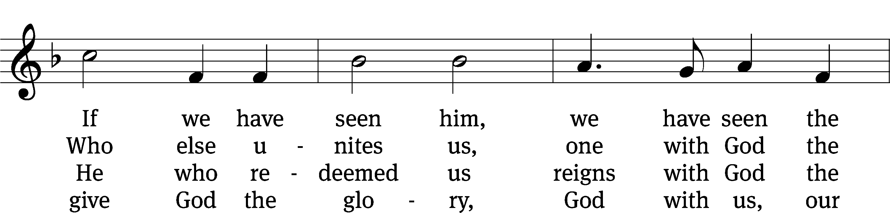
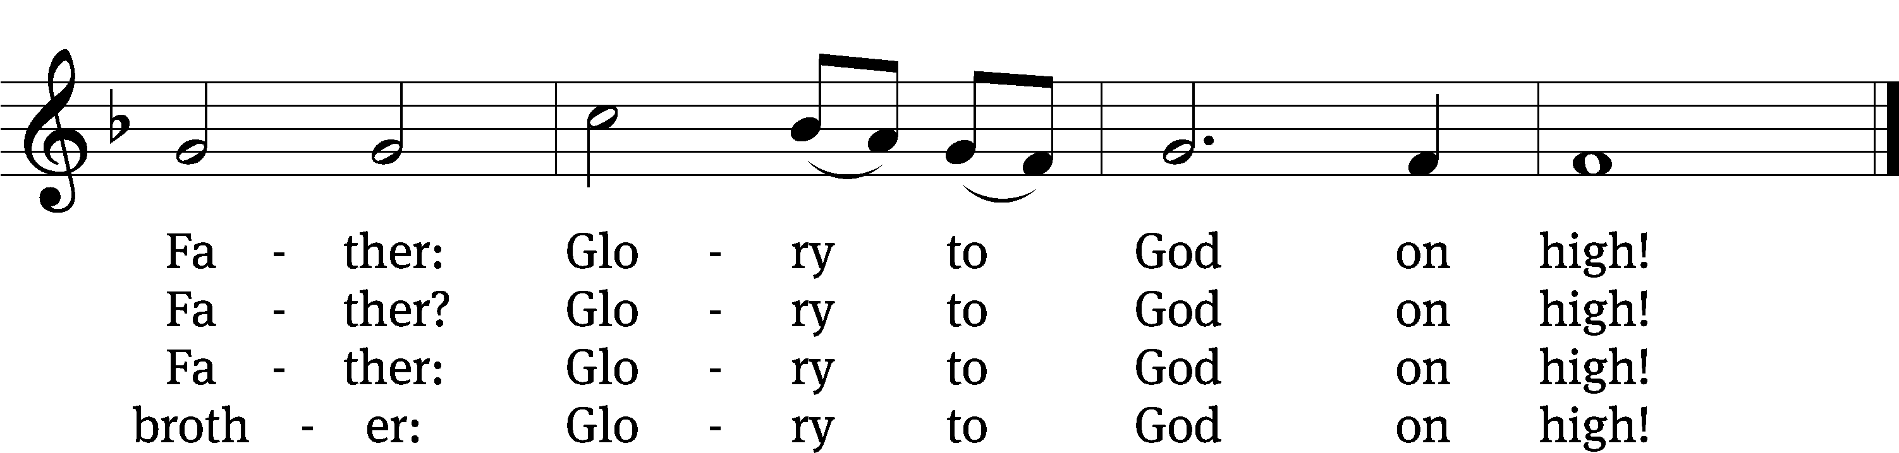
Text: Fred Pratt Green, 1903–2000, alt.
Tune: K. Lee Scott, b. 1950
Text: © 1969 Hope Publishing Co. Used by permission: OneLicense no. 703484
Tune: © 2004 Concordia Publishing House. Used by permission: License no. 130003205

Stand
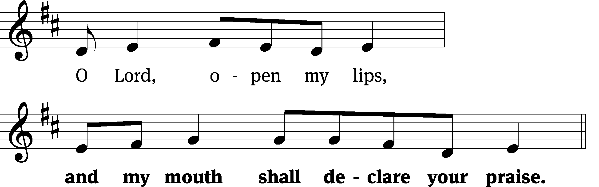
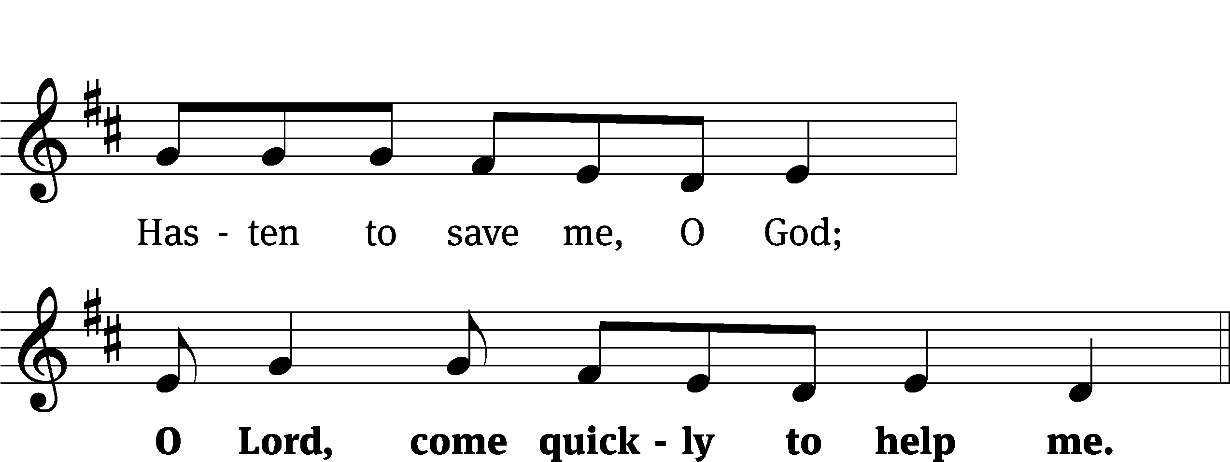

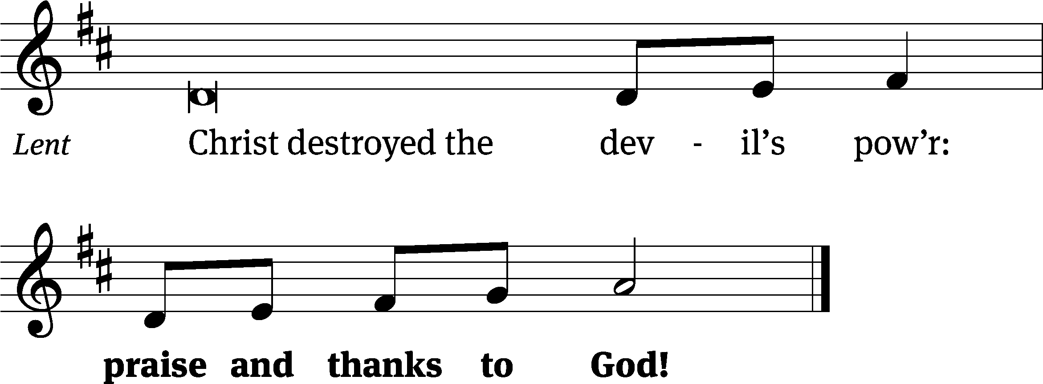

O Come, Let Us Sing to the Lord CW 208
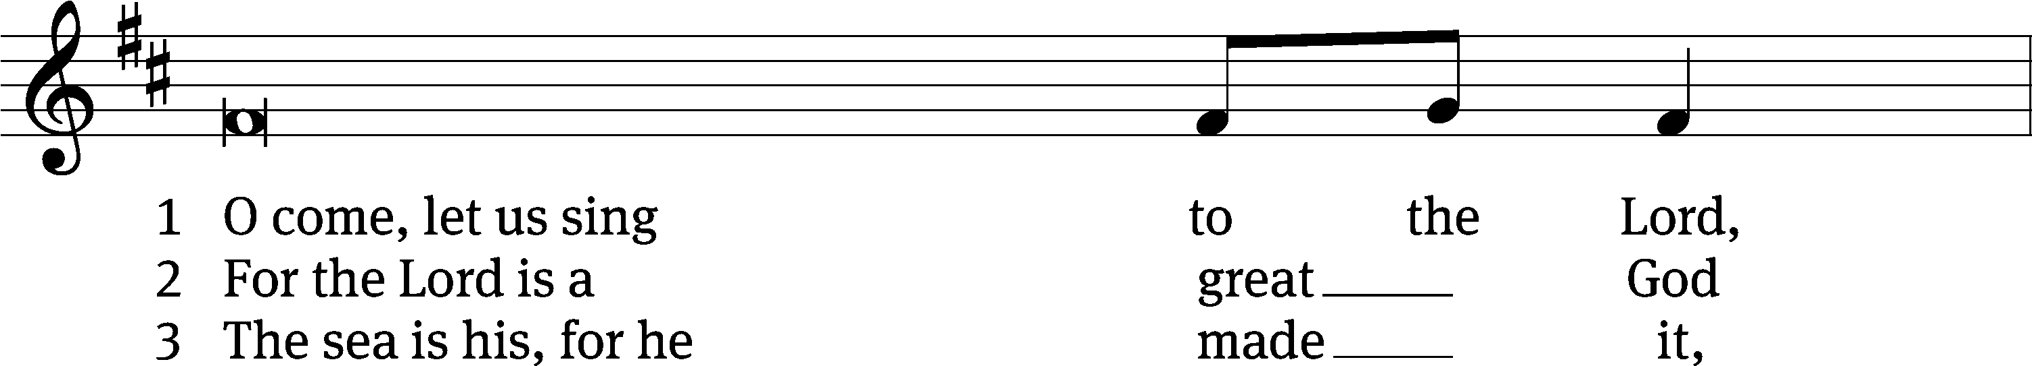
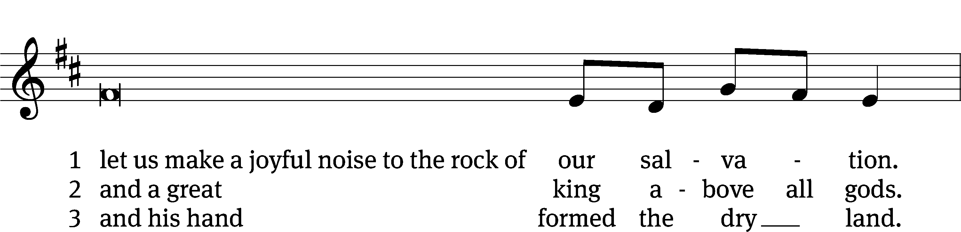
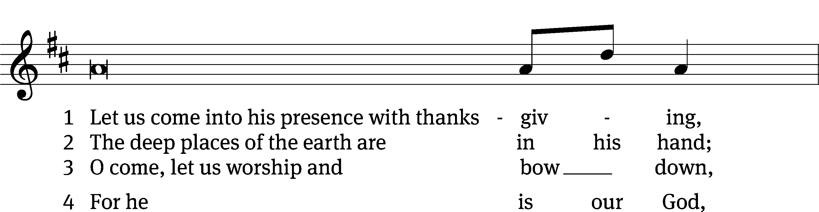
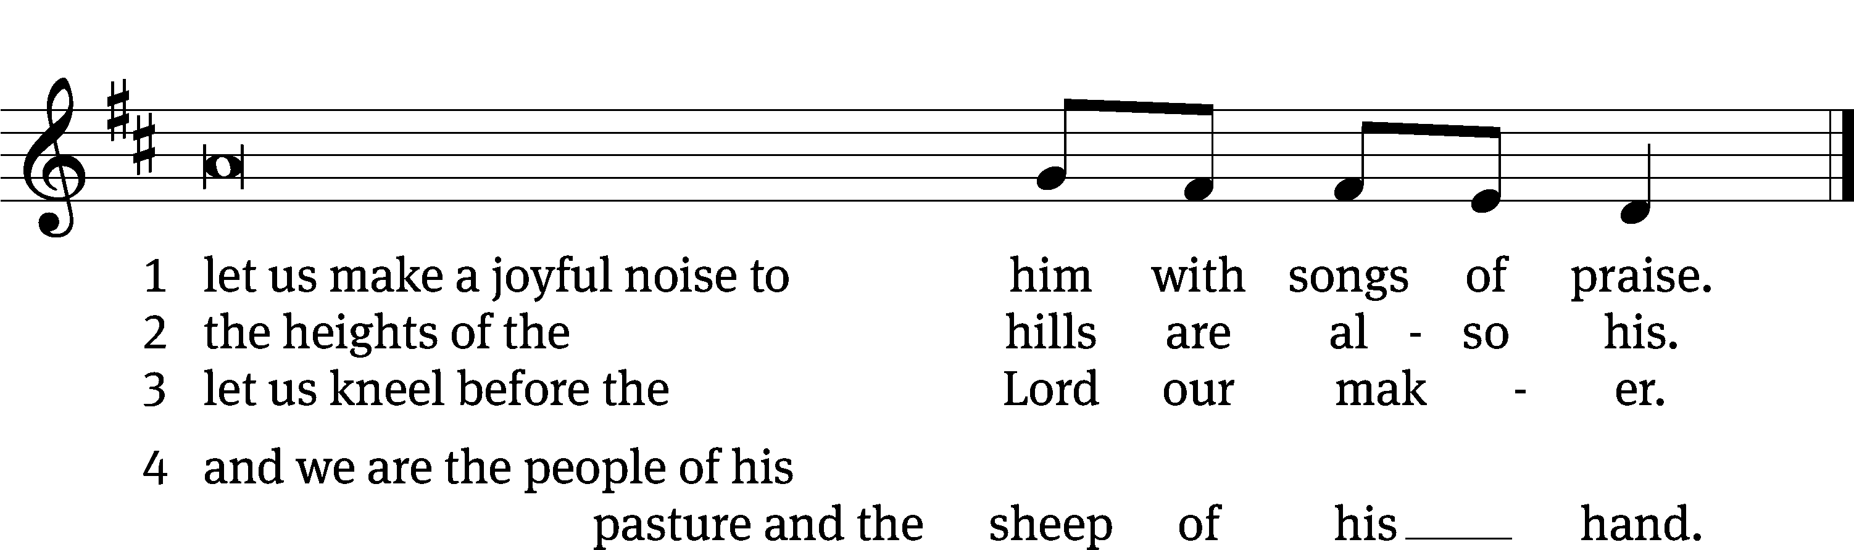
Be seated

Psalm
The LORD Is My Light and My Salvation Psalm 27C
Sung responsively with the minister
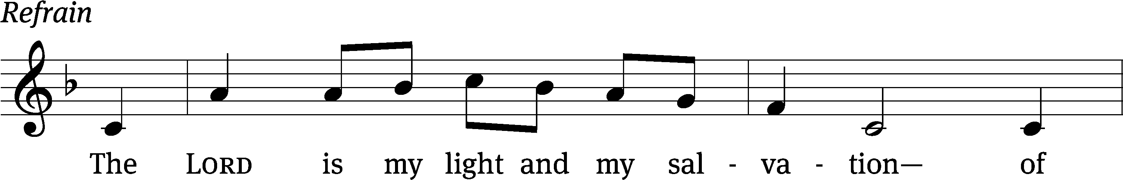
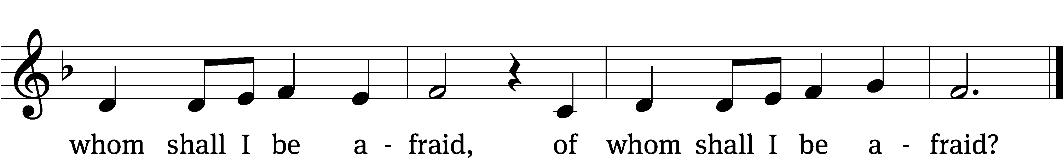

Hear my voice when I / call, Lord;
be merciful to me and / answer me.
Do not hide your / face from me,
do not turn your servant away in anger; you have been my / helper.
Do not reject me or for- / sake me,
God my / Savior. Refrain

Though my father and mother for- / sake me,
the Lord will re- / ceive me.
I remain confi- / dent of this:
I will see the goodness of the Lord in the land of the / living.
Wait / for the Lord;
be strong and take heart and wait / for the Lord.
Glory be to the Father and / to the Son
and to the Holy / Spirit,
as it was in the be- / ginning,
is now, and will be forever. / Amen. Refrain
Tune: David Haas
Tune: © 1983 GIA Publications, Inc. Used by permission: OneLicense no. 703484
Setting: © 1993 Kermit G. Moldenhauer, admin. Northwestern Publishing House. Used by permission: OneLicense no. 703484
First Reading Isaiah 42:14–21
14“For a long time I have kept silent,
I have been quiet and held myself back.
But now, like a woman in childbirth,
I cry out, I gasp and pant.
15I will lay waste the mountains and hills
and dry up all their vegetation;
I will turn rivers into islands
and dry up the pools.
16I will lead the blind by ways they have not known,
along unfamiliar paths I will guide them;
I will turn the darkness into light before them
and make the rough places smooth.
These are the things I will do;
I will not forsake them.
17But those who trust in idols,
who say to images, ‘You are our gods,’
will be turned back in utter shame.
18“Hear, you deaf;
look, you blind, and see!
19Who is blind but my servant,
and deaf like the messenger I send?
Who is blind like the one in covenant with me,
blind like the servant of the Lord?
20You have seen many things, but you pay no attention;
your ears are open, but you do not listen.”
21It pleased the Lord
for the sake of his righteousness
to make his law great and glorious.

The Word of the Lord.
Thanks be to God.

Second Reading Ephesians 5:8–14
8For you were once darkness, but now you are light in the Lord. Live as children of light 9(for the fruit of the light consists in all goodness, righteousness and truth) 10and find out what pleases the Lord. 11Have nothing to do with the fruitless deeds of darkness, but rather expose them. 12It is shameful even to mention what the disobedient do in secret. 13But everything exposed by the light becomes visible—and everything that is illuminated becomes a light. 14This is why it is said:
“Wake up, sleeper,
rise from the dead,
and Christ will shine on you.”

The Word of the Lord.
Thanks be to God.
Gospel John 9:1–7,13–17,34–39
1As he went along, he saw a man blind from birth. 2His disciples asked him, “Rabbi, who sinned, this man or his parents, that he was born blind?”
3“Neither this man nor his parents sinned,” said Jesus, “but this happened so that the works of God might be displayed in him. 4As long as it is day, we must do the works of him who sent me. Night is coming, when no one can work. 5While I am in the world, I am the light of the world.”
6After saying this, he spit on the ground, made some mud with the saliva, and put it on the man’s eyes. 7“Go,” he told him, “wash in the Pool of Siloam” (this word means “Sent”). So the man went and washed, and came home seeing.
13They brought to the Pharisees the man who had been blind. 14Now the day on which Jesus had made the mud and opened the man’s eyes was a Sabbath. 15Therefore the Pharisees also asked him how he had received his sight. “He put mud on my eyes,” the man replied, “and I washed, and now I see.”
16Some of the Pharisees said, “This man is not from God, for he does not keep the Sabbath.”
But others asked, “How can a sinner perform such signs?” So they were divided.
17Then they turned again to the blind man, “What have you to say about him? It was your eyes he opened.”
The man replied, “He is a prophet.”
34To this they replied, “You were steeped in sin at birth; how dare you lecture us!” And they threw him out.
35Jesus heard that they had thrown him out, and when he found him, he said, “Do you believe in the Son of Man?”
36“Who is he, sir?” the man asked. “Tell me so that I may believe in him.”
37Jesus said, “You have now seen him; in fact, he is the one speaking with you.”
38Then the man said, “Lord, I believe,” and he worshiped him.
39Jesus said,“For judgment I have come into this world, so that the blind will see and those who see will become blind.”

The Gospel of the Lord.
Praise be to you, O Christ!

Awake, O Sleeper, Rise and See CW 691
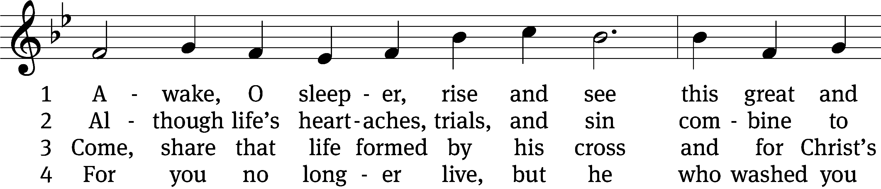
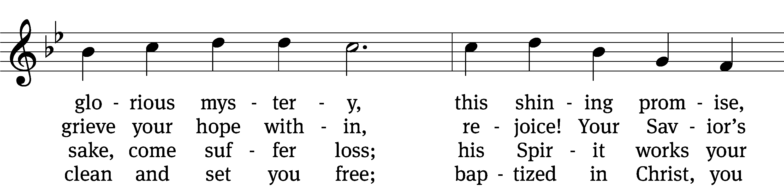
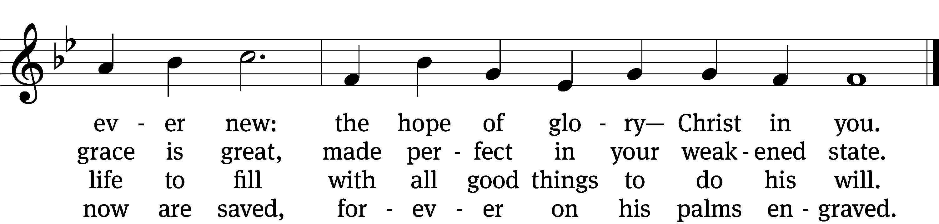
5 Christ offers you, with nail-scarred hand,  true manna for this desert land:  his body and his blood divine  beneath the sacred bread and wine. | 6 Our Savior never leaves his own  as orphans, hungry and alone;  he promises with certainty:  “I am in you and you in me.”
Text: Stephen P. Starke, b. 1955
Tune: Geistliche lieder auffs new gebessert, Wittenberg, 1533, ed. Joseph Klug
Text: © 2005 Stephen P. Starke, admin. Concordia Publishing House. Used by permission: OneLicense no. 703484
Tune: Public domain

7 Such precious gifts do not disdain;
do not receive God’s grace in vain,
but cherish, as his children true,
the hope of glory—Christ in you.

Children’s Sermon Children may come
forward to the front pew

Sermon Isaiah 42:14-21
God’s Word is Great and Glorious

Joyously I’ll Praise My Savior CW 611
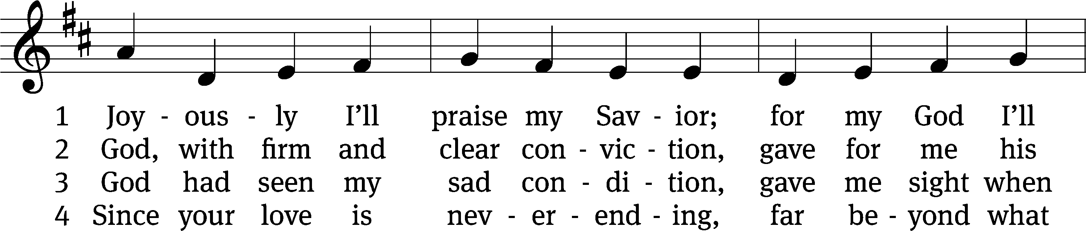
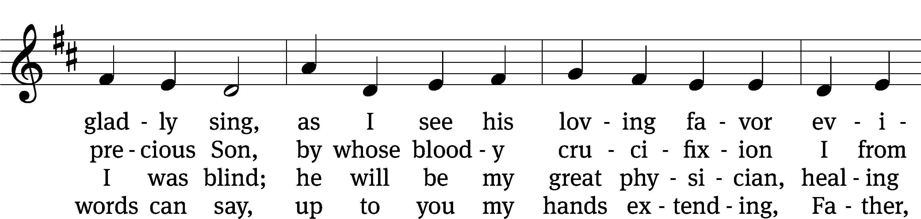
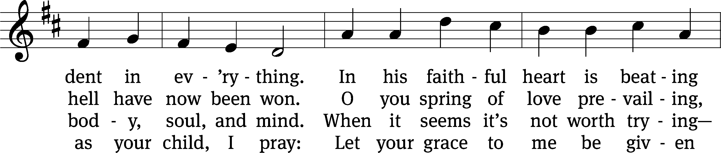
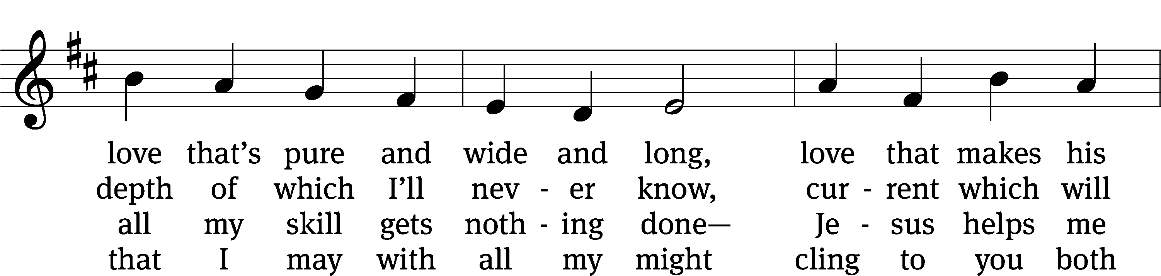
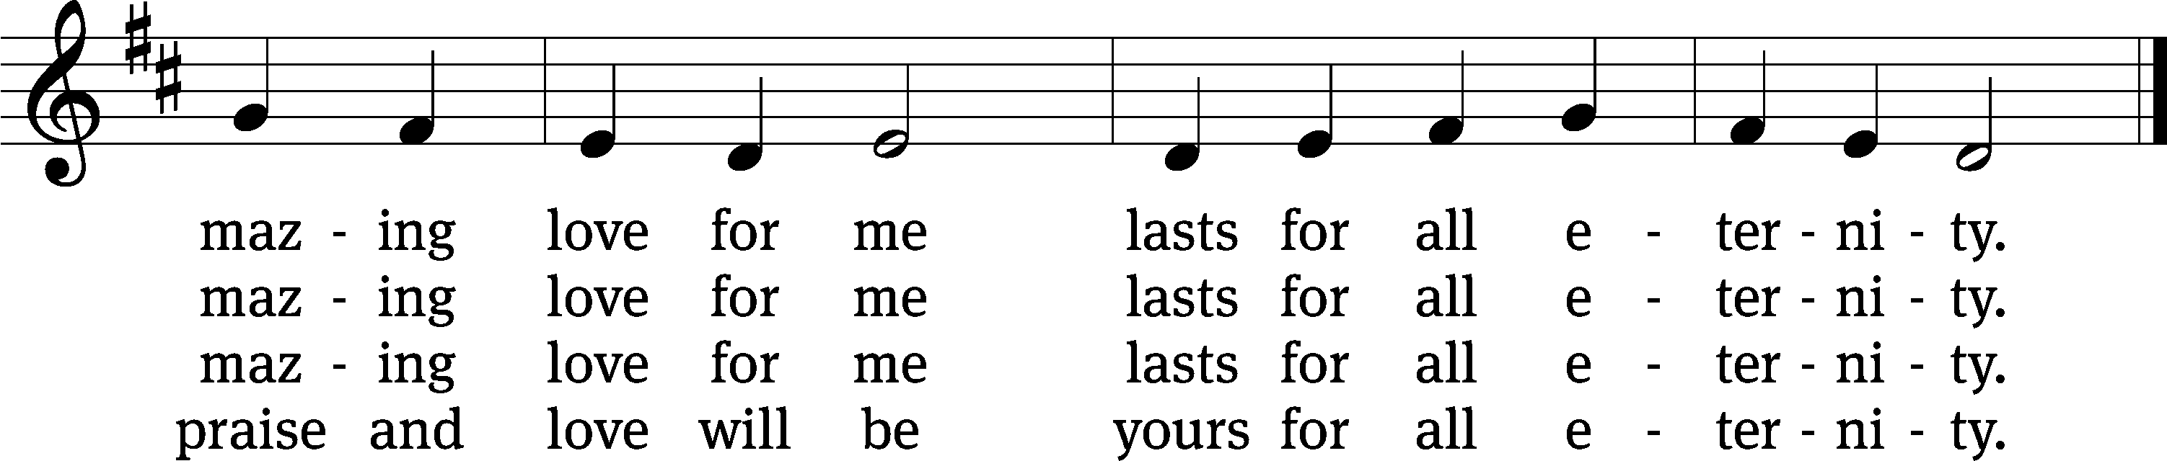
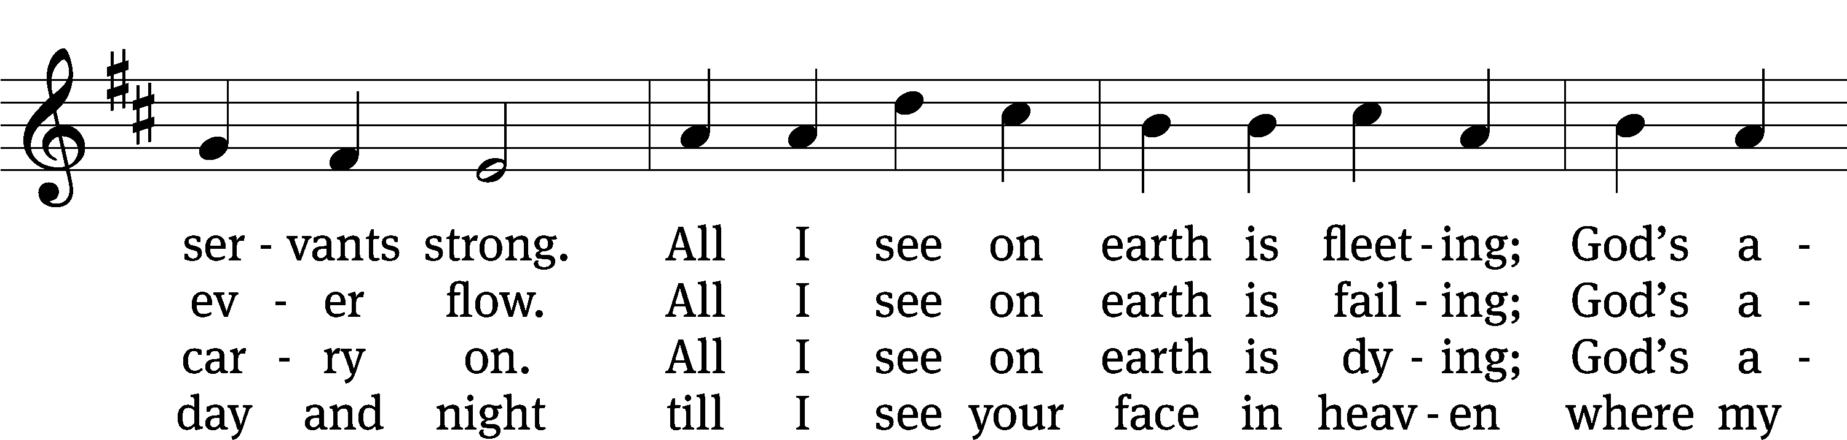

Text: tr. Michael D. Schultz, b. 1963; Paul Gerhardt, 1607–1676, abr.
Tune: Georg G. Boltze, 18th cent.
Text: © 2021 Northwestern Publishing House. Used by permission: OneLicense no. 703484
Tune: Public domain

Be seated

The offering may follow.

Lord, Have Mercy CW 213
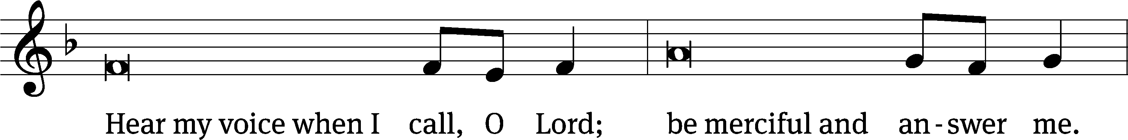
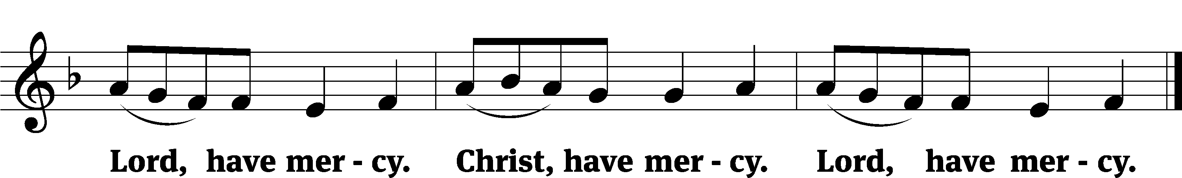

Prayers of intercession, seasonal prayers, and the Prayer of the Day may follow.

Prayer of the Day
Let us pray.
O Lord Jesus Christ, by your almighty power you opened the eyes of the blind and showed yourself to them. Turn our eyes away from worthless things, and lead us to love you sincerely; for you live and reign with the Father and the Holy Spirit, one God, now and forever.
Amen.

The following prayer is said:

O Lord, our heavenly Father, almighty and everlasting God, you have brought us safely to this new day. Defend us with your mighty power, and grant that this day we neither fall into sin nor run into any kind of danger. And in all we do, direct us to what is right in your sight; through Jesus Christ, your Son, our Lord.
Amen.

Lord’s Prayer
Our Father in heaven,
hallowed be your name,
your kingdom come,
your will be done
on earth as in heaven.
Give us today our daily bread.
Forgive us our sins,
as we forgive those
who sin against us.
Lead us not into temptation,
but deliver us from evil.
For the kingdom, the power,
and the glory are yours
now and forever. Amen.

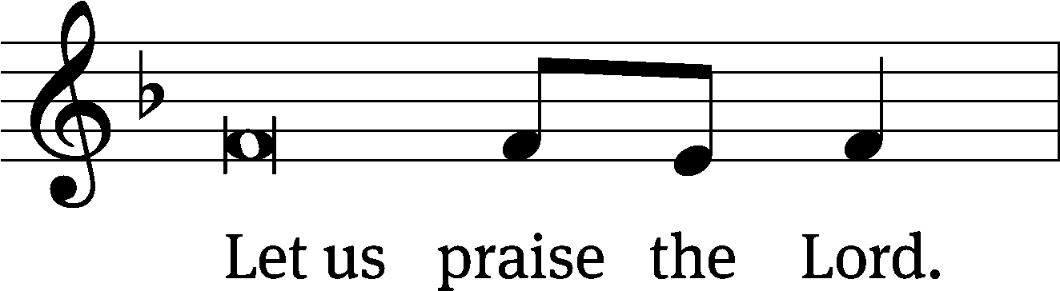
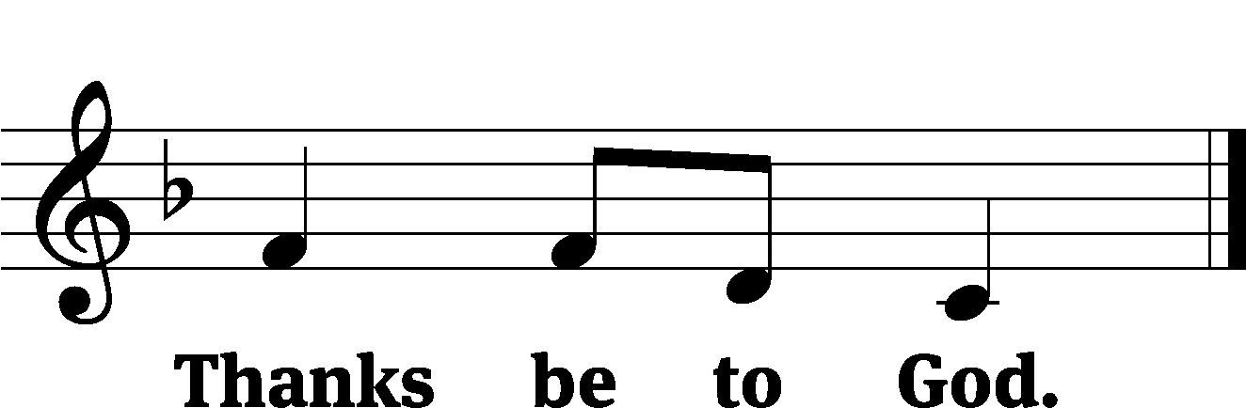

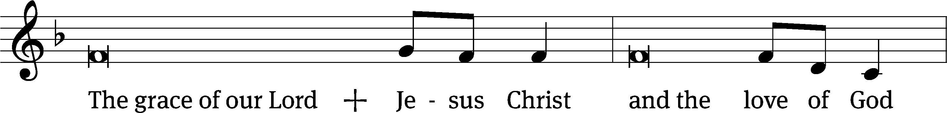
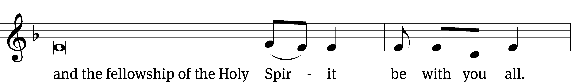

Amazing Grace CW 576
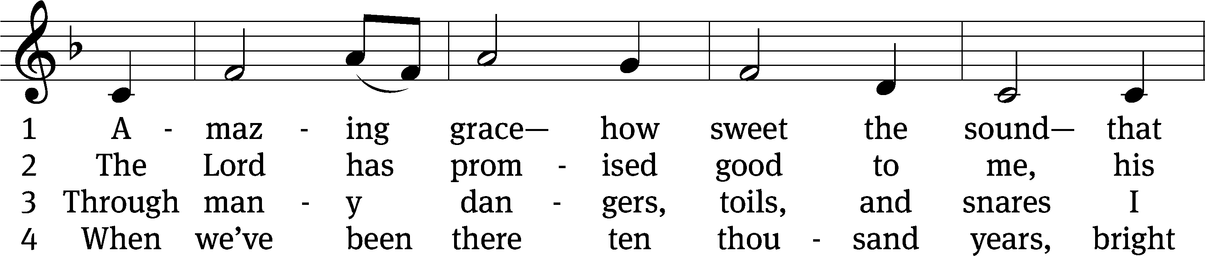
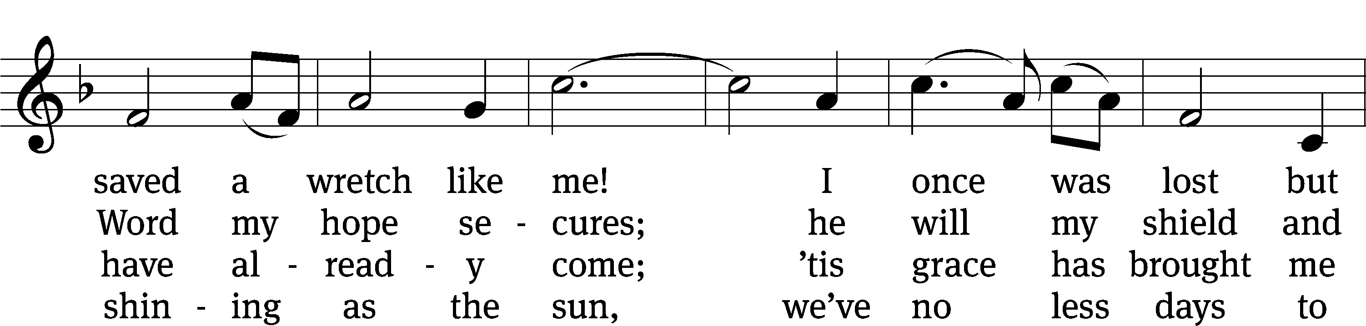
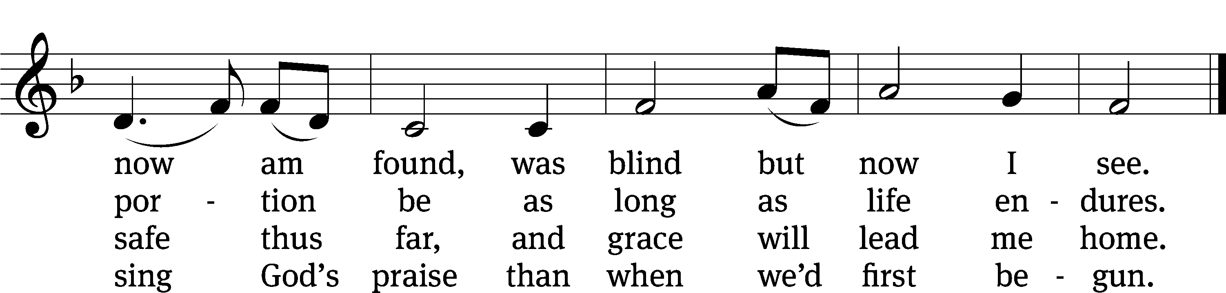
Text (sts. 1–3): John Newton, 1725–1807, alt.; (st. 4): A Collection of Sacred Ballads, Richmond, 1790
Tune: Columbian Harmony, Cincinnati, 1829, ed. Benjamin Shaw; ed. Charles H. Spilman
Text and tune: Public domain
Acknowledgments
Morning Prayer from Christian Worship
Unless otherwise indicated, Scripture quotations are from The Holy Bible, New International Version®, NIV®. Copyright © 1973, 1978, 1984, 2011 by Biblica, Inc.TM Used by permission of Zondervan. All rights reserved worldwide.
Software distributed in partnership with Northwestern Publishing House.
Created by Christian Worship: Service Builder © 2023 Concordia Publishing House.

Announcements

Forward Capital Campaign the Big Give: Now is your opportunity to commit to working together to make the vision of a new church building a reality. If you have not done so, over the next few weeks return a commitment card outlining your gift to the Lord for the purpose of building his house. That gift is one way of thanking the Lord for all he has given you. Commitment forms are available online, in the back of church, and outside the school office. They may be placed in the red box in the back of church, or dropped off at the office during the week.

To kick off the giving season, we will be holding “The Big Give” on the weekend of March 18 & 19. This is a chance to get the ball rolling, to give a boost to the building fund as we start the gathering phase of the capital campaign. Consider giving a down payment on the commitment you have made for the capital campaign. The offerings given in The Big Give will help us keep moving forward on this project. Simply place your check in a church building fund envelope, or donate online through our website. We pray that the Lord blesses all of us with the joy of giving cheerfully.

Easter Breakfast: Easter breakfast will be served 7:00—8:15 am. A sign up sheet for food donations and volunteers to prepare and clean up are in the church entry.

Easter Lilies: Memorial Easter Lily order forms are in the church entry.

Lutheran Women's Missionary Society Mission Box will be in the back of church the next two weekends. Funds gathered by the LWMS provide for mission projects not funded by the synod budget.

LUTHERAN WOMENS MISSIONARY SOCIETY SPRING RALLY
Saturday, April 15th at Good Shepherd, 777 S. Decorah Rd., West Bend Registration will begin at 8:30. Rally begins at 9 and concludes at 12:30. Stefan Felgenhauer (World Mission Operations Director) and his wife Kathy will be our speakers. He and his wife are world travelers who have lived and served in many of our mission fields. Born in East Germany, Stefan will tell us of his journey to Christianity.

Donations for our Working Fund and Seminary food bank will be taken at registration. Most needed items are toilet paper, laundry detergent, non-perishable foods, crackers, cereals, and
cash. Babysitting provided upon request.
New altar guild and usher schedules are available in the church entry. The schedule runs through Labor Day weekend.

Wisconsin Parental Choice Program The enrollment window is now open! Apply for the WPCP between February 1st and April 20th. To apply for a voucher, go to dpi.wi.gov/choice, verify your income and submit proof of residency. We hope this program can be a blessing to our St. Lucas families and allow us to share the light of God's Word even more. If you have questions please contact Kevin Scheunemann, school choice administrator, at (262) 339-5425 or kewaskumdq@gmail.com or Mr. Hesse.

2022 Offering Statements are on a table in the back of church, on the left side as you leave.

St. Paul Little Learners Preschool and Childcare in Slinger is accepting applications for part-time or full-time teachers in our childcare as well as summer positions. no nights or weekends! Must be over 18 with a background in education or be willing to take at least one class. Contact Lisa Meissner: 262-644-8295 ext. 1 littlelearners@stpaulslinger.org

Opportunity to Serve
Lutheran Memorial Park is in need of one or two people for mowing and trimming of the Cemetery grounds. This is an ideal opportunity for anyone who enjoys being outside in summer, riding on a lawn mower and trimming. If there is multiple interest, duties can be shared or split. All equipment is provided. Pay is hourly. For further information, contact Sexton Richard Schmidt at 262-626-4593 or Chairman Paul Lemke at 262-626-4829. Thank you for considering serving the Lord and our Congregation.

Midweek Lenten Series: His final Steps
March 22 His Final Steps Led to His Father’s House — Pastor Loescher, David’s Star Jackson
March 29 His Final Steps Led to a Fig Tree — Pastor Rohrback — Redeemer Cedarburg

Services will be held each Wednesday at 3:30 pm and 6:30 pm
A soup supper will be served in the school gymnasium between the services.

Celebrating God’s blessings this week

Birthdays

Betty Ebert – 3/19  Ethan Seefeldt – 3/19  Jonathan Koch – 3/21 | Richard Thiemer – 3/22  Pam Jeserig – 3/24  Joshua Kertscher – 3/24
Calendar
Readings for March 20 – March 26
Saturday: | Genesis 41:1-27; Mark 11:1-19
 | Worship 6:00 pm | Usher: | Butzke
Sunday: | Genesis 41:28-57; Mark 11:20-33
 | Worship 8 or 10:30 am | Ushers: | Kempf 8am
 | Sunday School and Bible Hour 9:15 am |  | Koch 10:30am
Monday: | Genesis 42:1-34:38; Mark 12:11-12
Tuesday: | Genesis 43:1-28; Mark 12:13-27
Wednesday: | Genesis 44:1-18,32-34; Mark 12:28-44
 | Soup supper 4:30 pm
 | Worship 6:30 pm
Thursday: | Genesis 45:1-20, 24-28; Mark 13:1-23
 | Bible Study 10:00 am
Friday: | Genesis 47:1-31; Genesis 48:1-49:28; Mark 13:24-37
 | School Chapel Service 7:45 am
Saturday: | Genesis 49:29-50:7, 14-26; Mark 14:1-11
 | Worship w/communion 6:00 pm | Usher: | Peters
Sunday: | Exodus 1:1-22; Mark 14:12-31
 | Worship w/communion 8 or 10:30 am | Ushers: | Stolz 8am
 | Sunday School 9:15 am |  | Wolter 10:30am

St. Lucas Lutheran Church strives to be a congregation that is
always inviting, always edifying, and always equipping.
www.stlucaswels.org

Contact Information
Pastor Timothy Henning - 262-707-6984 thenning@stlucaswels.
Principal Mark Hesse - 920-915-1130 mhesse@stlucaswels.org
School/Church Office - 262-626-2680 church@stlucaswels.org

